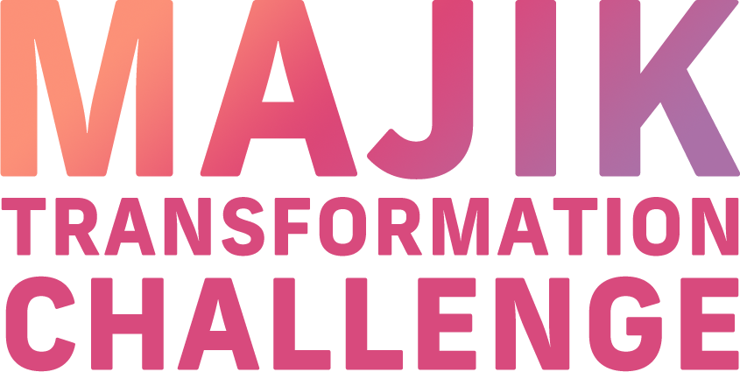


EXPERIENCE JOURNAL

This journal template serves as a guide, and you can customize it according to your personal journey and experiences. Regular reflection and documentation can be incredibly powerful in a transformative journey like a weight loss challenge.

• Make daily or weekly entries.
• Feel free to write daily or weekly thoughts, feelings, challenges, and victories.
• Document any significant moments or turning points in your journey.

Basic Information
Your name:
Challenge start date:
Challenge end date:
Number of days:

Age:
Gender:

Starting measurements
Weight:
Waist:

Ending measurements
Weight:
Waist:

Entries Template

Pre-Challenge Entry
Date:

Mindset and Expectations
• How do you feel about starting this challenge?
• What are your main goals?
Examples of goals:
• Drink at least 8 glasses of water daily for the next 90 days.
• Lose 8 pounds in the next two months.
• Exercise for a minimum of 30 minutes every day.
• Limit the intake of processed foods and sugary drinks.
• Write about your expectations and any concerns you might have.

Community and Support
We suggest that you invite friends and family to participate in this health transformation challenge with you. Additionally, consider seeking out an online group or community for larger support and encouragement.

Week 1: Getting Started
Initial Observations
• How has the first week been?
• What changes have you made in your diet or exercise routine?
• Describe your energy levels and mood.
• What supplements are you adding to your diet?
• Please keep track of the following in your fitness journal: your weight, exercise activities, daily water intake, duration of sleep, and your overall mood.

Week 2: Building Momentum
Early Challenges and Successes
• What obstacles have you faced so far?
• Share any successes or improvements you’ve noticed.
• What supplements are you using?
• Please keep track of the following in your fitness journal: your weight, exercise activities, daily water intake, duration of sleep, and your overall mood.

Week 3: Weekly Check-ins
Progress and Adjustments
• Track your weight and any other measurements you’re using.
• What adjustments have you made to your routine?
• Share any new recipes or exercises you’ve tried.
• What supplements are you using?
• Please keep track of the following in your fitness journal: your weight, exercise activities, daily water intake, duration of sleep, and your overall mood.

Week 4: Weekly Check-ins
Progress and Adjustments
• Track your weight and any other measurements you’re using.
• What adjustments have you made to your routine?
• Share any new recipes or exercises you’ve tried.
• What supplements are you using?
• Please keep track of the following in your fitness journal: your weight, exercise activities, daily water intake, duration of sleep, and your overall mood.

Week 5: Weekly Check-ins
Progress and Adjustments
• Track your weight and any other measurements you’re using.
• What adjustments have you made to your routine?
• Share any new recipes or exercises you’ve tried.
• What supplements are you using?
• Please keep track of the following in your fitness journal: your weight, exercise activities, daily water intake, duration of sleep, and your overall mood.

Week 6: Weekly Check-ins
Progress and Adjustments
• Track your weight and any other measurements you’re using.
• What adjustments have you made to your routine?
• Share any new recipes or exercises you’ve tried.
• What supplements are you using?
• Please keep track of the following in your fitness journal: your weight, exercise activities, daily water intake, duration of sleep, and your overall mood.

Mid-Challenge Reflection
Date:

• Reflect on your journey so far.
• How has your mindset evolved?
• What keeps you motivated?
• What supplements are you using?
• Please keep track of the following in your fitness journal: your weight, exercise activities, daily water intake, duration of sleep, and your overall mood.

Overcoming Plateaus
• Challenges and Resilience
• Discuss any plateaus or setbacks.
• How are you planning to overcome them?

Week 7: Weekly Check-ins
Progress and Adjustments
• Track your weight and any other measurements you’re using.
• What adjustments have you made to your routine?
• Share any new recipes or exercises you’ve tried.
• What supplements are you using?
• Please keep track of the following in your fitness journal: your weight, exercise activities, daily water intake, duration of sleep, and your overall mood.

Week 8: Weekly Check-ins
Progress and Adjustments
• Track your weight and any other measurements you’re using.
• What adjustments have you made to your routine?
• Share any new recipes or exercises you’ve tried.
• What supplements are you using?
• Please keep track of the following in your fitness journal: your weight, exercise activities, daily water intake, duration of sleep, and your overall mood.

Week 9: Weekly Check-ins
Progress and Adjustments
• Track your weight and any other measurements you’re using.
• What adjustments have you made to your routine?
• Share any new recipes or exercises you’ve tried.
• What supplements are you using?
• Please keep track of the following in your fitness journal: your weight, exercise activities, daily water intake, duration of sleep, and your overall mood.

Week 10: Weekly Check-ins
Progress and Adjustments
• Track your weight and any other measurements you’re using.
• What adjustments have you made to your routine?
• Share any new recipes or exercises you’ve tried.
• What supplements are you using?
• Please keep track of the following in your fitness journal: your weight, exercise activities, daily water intake, duration of sleep, and your overall mood.

Week 11: Gearing Up for the End
• What strategies are you implementing for the final weeks?
• How do you feel about the upcoming end of the challenge?
• Reflect on your overall journey.

Week 12: Final Reflections
• Did you meet your goals?
• What have you learned about yourself?
• Plans for maintaining your weight loss and health improvements.

